



Business Requirement Document
Supply Chain Management
NWS Tender Fee Collection
DOCUMENT FOR

Table of Contents:
Table of Contents: 1
1. Introduction 3
1.1 Business Need 3
1.2 Expected Business Outcomes 3
1.3 Project Scope Summary 3
2. Business Requirement Details 4
2.1 Requirement Description 4
2.2 Functional Requirements 5
2.3 Non-Functional Requirements 6
3. System Integration 6
4. Payment Details 7
5. Process Flow 7
5.1 Tender Owner and Supplier Interaction Flow 7
5.2 Payment and Acknowledgment Flow 7
5.3 API Integration Flow 8
5.4 Process Flow 8
6. Assumptions & Constraints 9
7. Risks & Mitigation 9
8. Application Prototype 10
9. Open and Close Issues 11
9.1 Open Issues 11
9.2 Closed Issues 11

Introduction
x

1.1 Business Need
Currently, the Nama Water Services (NWS) tendering process needs controlled mechanism to manage tender fee collection, supplier eligibility validation, and automatic supplier inclusion for tender participation. This requirement aims to automate and streamline the tender participation process by introducing a custom Tender Fee functionality integrated with Oracle Fusion.

1.2 Expected Business Outcomes
- Automated tender fee handling, exemption, and validation with real-time supplier grade verification before payment.
- Enhanced supplier experience through a unified payment and validation process, with restrictions on accessing tender documents and submitting tenders until payment completion.
- Transparent eligibility checks based on supplier grade.
- Streamlined tender participation and payment reconciliation.
- Automatic AR integration to ensure financial accuracy, enhancing governance and maintaining a clear audit trail for tender participation.
- Reduced manual coordination between suppliers and tender owners.

1.3 Project Scope Summary
The scope of this Application covers:
- Custom development of a Tender Fee Page integrated with Oracle Fusion Sourcing and Supplier Porta module.
- Supplier grade and Riyada classification validation.
- Integration with Bank Muscat payment gateway for fee collection.
- Automatic AR receipt creation and tender document acknowledgment notification.
- Integration APIs to update Oracle Fusion’s ‘Note to Buyer’ field and supplier invitation for open tenders.
- Enablement of the supplier tender submission button based on payment or exemption status.

2. Business Requirement Details

2.1 Requirement Description
The Tender Owner will create a Tender Fee based RFQ in Oracle Fusion and define the Tender Fee, Required Supplier Grades, and Tender Type (Open/Closed). For Open Tenders, the notification will be automatically sent by Oracle Fusion to eligible suppliers, while for Closed Tenders, the details will be shared to NWS Website. Suppliers will access the Oracle Fusion portal, view tender overview details, but the tender submission and main document download options will remain disabled until payment or exemption validation is completed.
When suppliers click the 'Make Payment' button, the system redirects them to a custom Tender Fee page that displays prepopulated details such as Supplier Name, Supplier Type, Riyada Certificate Expiry Date, Supplier Grade, Riyada Number, Payment Status, Tender Number, and Tender Title.
The system will validate the Supplier Grade with the Tender Grade defined in RFQ:
- If matched, payment is allowed.
- If not matched, the message 'Grade Not Matched' is displayed and payment is not allowed.
For Riyada suppliers, the system will skip the payment step, display 'Exempted from Tender Fee,' and update the 'Note to Buyer' field as 'Exempted'. The system will automatically add these suppliers to the invited list via API for Open Tenders and enable the Submit button on the RFQ page.
For Non-Riyada suppliers, the system redirects them to the Bank Muscat payment gateway. Upon successful payment, acknowledgment is sent to both supplier and tender owner, a link to the tender document is shared, and the ‘Note to Buyer’ field is updated as 'Paid.' The supplier is then added to the invited supplier list via API, and the Submit button is enabled. AR integration will record the transaction in Oracle Fusion Accounts Receivable.

2.2 Functional Requirements
Functional Requirement | Detailed Description
Tender Owner Configuration | Tender Owner defines Tender Fee, Supplier Grade, and Tender Type while creating the RFQ.
Supplier Access Restriction | Suppliers can view tender details but cannot access documents or submit until payment/exemption.
Grade Validation | Supplier Grade is checked against tender grade setup. If not matched, payment is blocked.
Riyada Fee Exemption | Riyada suppliers are automatically exempted from payment with message 'Exempted from Tender Fee'. Note to Buyer updated as 'Exempted'.
Payment Gateway Integration | Integration with Bank Muscat payment gateway for online fee payment.
Acknowledgment Notification | System sends acknowledgment email and tender document link post successful payment/exemption.
API Integration | System updates 'Note to Buyer' and adds supplier to the invited supplier list for open tenders via API.
AR Integration | Automatic AR receipt creation in Oracle Fusion upon successful payment.
Submit Button Enablement | Submit button is enabled when Note to Buyer is 'Paid' or 'Exempted'.

2.3 Non-Functional Requirements
- Data encryption via HTTPS during transmission.
- System should support 100% availability.
- Page load response time under 3 seconds.
- Scalable for high concurrent supplier usage.
- Complete audit trail for every action and system integration log.

3. System Integration
System | Module | Integration Point
Oracle Fusion | Sourcing | Tender Fee RFQ creation and supplier response page integration.
Custom Tender Fee Page | Supplier Portal | Supplier detail prepopulation, payment initiation, grade validation.
Bank Muscat Gateway | Payment Gateway | Real-time payment confirmation callback.
Oracle Fusion | Accounts Receivable | Automatic AR receipt creation and payment accounting.
Custom API | Integration Layer | Updates Note to Buyer field and adds suppliers to invited list.

4. Payment Details
Payment Gateway: Bank Muscat
Tender Fee: Defined by Tender Owner per RFQ
Exemption: Riyada Supplier Type
Payment Method: Credit/Debit Cards, Bank Transfers
AR Integration: Automatic AR Receipt creation in Oracle Fusion

5. Process Flow

5.1 Tender Owner and Supplier Interaction Flow
1. Tender Owner creates Tender Fee based RFQ.
2. Supplier views RFQ in Oracle portal.
3. Supplier clicks 'Make Payment'.
4. Custom page loads supplier details and tender info.
5. System performs grade validation.

5.2 Payment and Acknowledgment Flow
6. If supplier is Riyada, exemption is applied and invitation sent automatically (Open Tender only).
7. If non-Riyada, supplier proceeds to payment gateway.
8. Payment confirmation triggers AR receipt creation.
9. Email acknowledgment and tender document link sent.
10. Submit button enabled in Oracle RFQ page.

5.3 API Integration Flow
Custom APIs handle “Note to Buyer” field updates and supplier invitation synchronization between custom page and Oracle Fusion for open tenders.

5.4 Process Flow
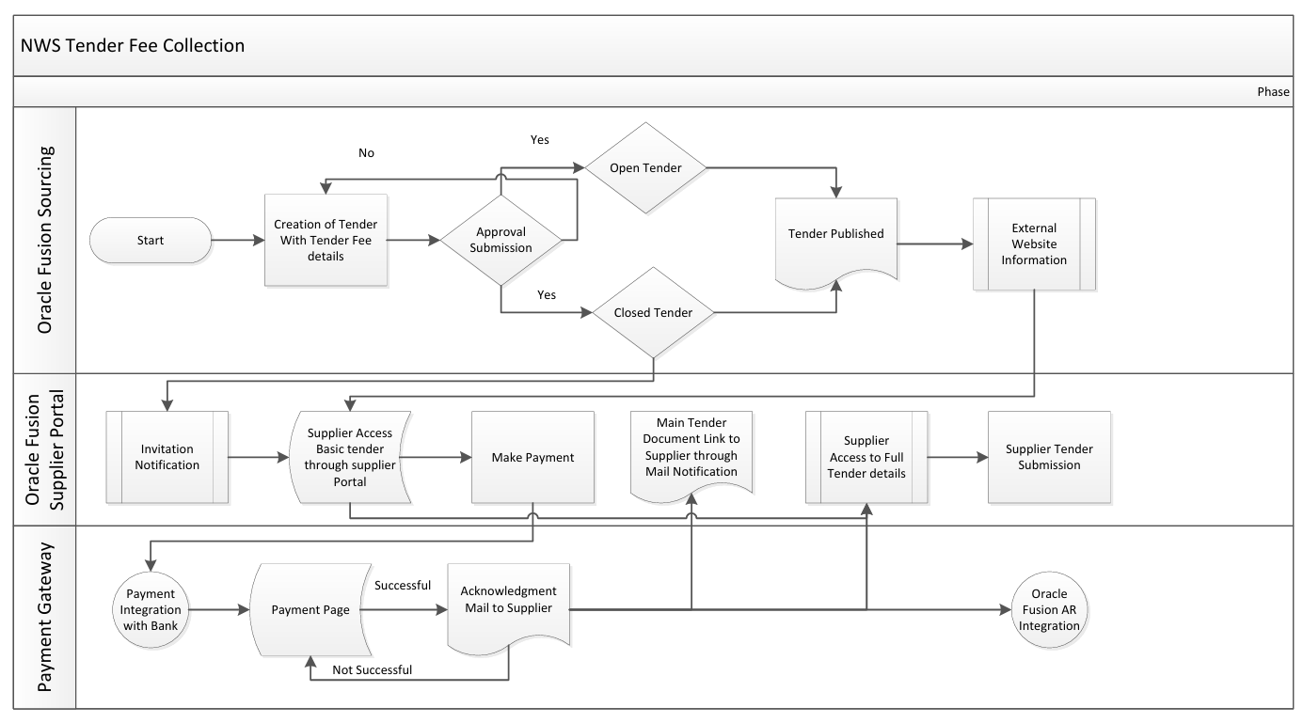

6. Assumptions & Constraints
- Payment gateway operates within standard SLA.
- No refund for tender fee once paid.
- Tender Owner configures accurate supplier grades and any new round of tender the supplier payment details will be transferred to the new round.
- Integration services between Oracle and custom layer remain active.
- Audit log must capture each payment and exemption event.

7. Risks & Mitigation
Risk | Impact | Mitigation
Grade mismatch configuration | Suppliers may be incorrectly restricted | Add validation controls during RFQ creation.
Missing Tender | Payment Fails | Add validation controls during RFQ creation.
Payment Gateway Downtime | Suppliers cannot pay fee | Implement retry and alternate payment route.
API Failure | Supplier not invited automatically | Queue and retry mechanism with alert notifications.
Delayed AR Sync | Payment not visible in Fusion immediately | Batch reconciliation job setup.

8. Application Prototype
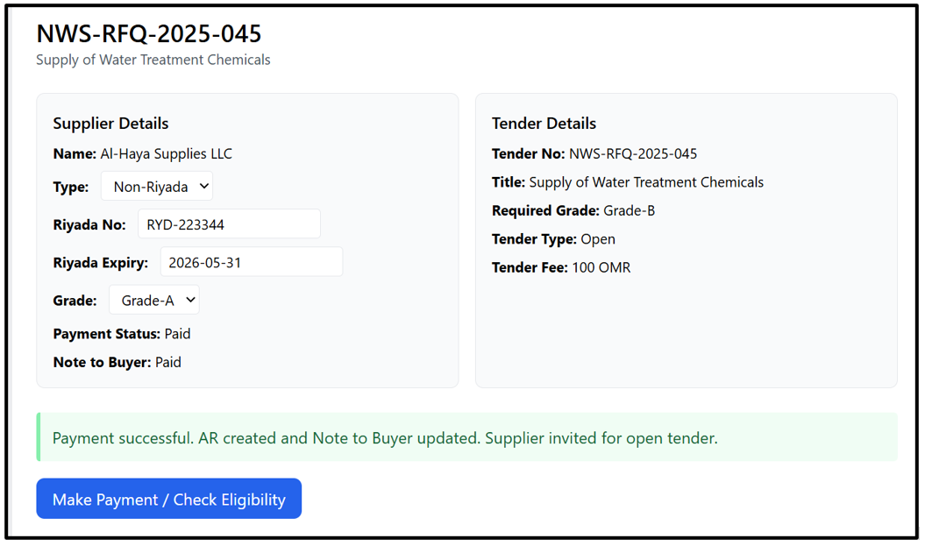

9. Open and Close Issues

9.1 Open Issues
S. No | Issue | Resolution | Responsibility | Target Date | Impact Date
1
2

9.2 Closed Issues
S. No | Issue | Resolution | Responsibility | Target Date | Impact Date
1
2

